**Lab No 11**

**Name : Muhammad Faizan Reg. No. : 21-NTU-CS-1258**

**(Q1)**

#include<iostream>

using namespace std;

void asterisk(int *a)

{

for(int i=1;i<=*a;i++)

{

cout<<"*";

}

}

int main()

{

int num;

cout<<"Enter a integer ";

cin>>num;

asterisk(&num);

return 0;

}

**Output**

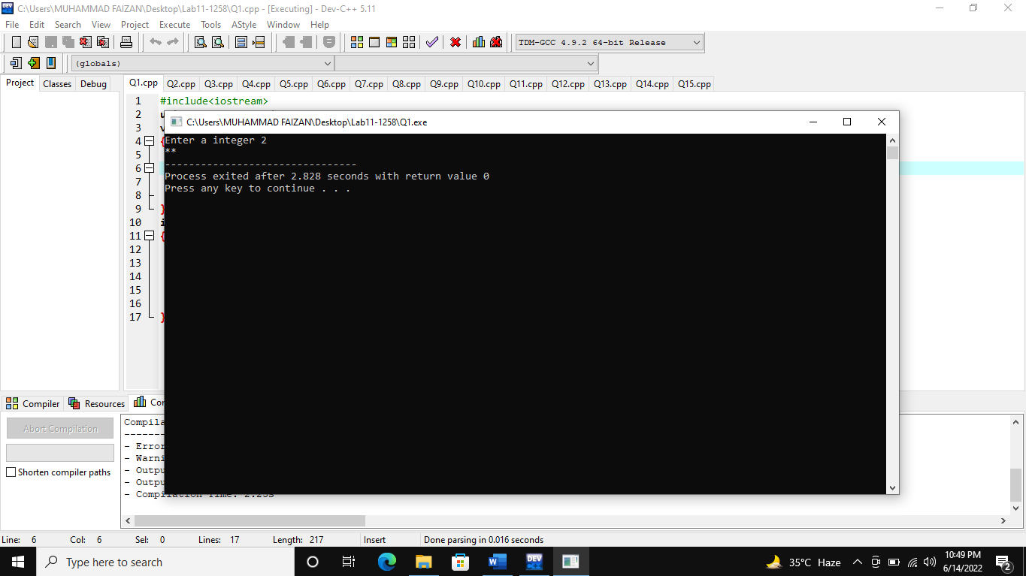

**(Q2)**

#include<iostream>

using namespace std;

void rectangle(int *num, char *ch)

{

for(int i=1;i<=*num;i++)

{

for(int j=0;j<=*num;j++)

{

cout<<*ch;

}

cout<<endl;

}

}

int main()

{

int num;

char ch;

cout<<"Enter a integer for size: ";

cin>>num;

cout<<"Enter a character: ";

cin>>ch;

cout<<"===================="<<endl;

rectangle(&num,&ch);

}

**Output**

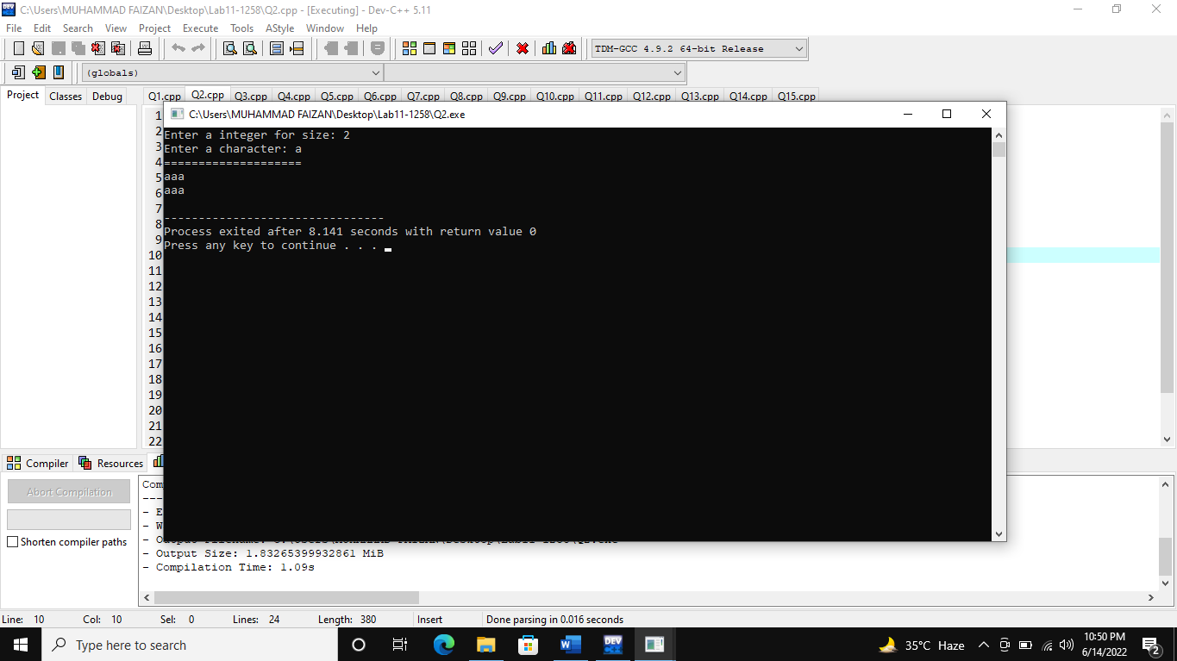

**(Q3)**

#include<iostream>

using namespace std;

void avg(int *num1,int *num2,int *num3,int *num4,int *num5)

{

float avg;

int sum=0;

sum=*num1+*num2+*num3+*num4+*num5;

avg=sum/5.0;

cout<<"The average is "<<avg;

}

int main()

{

int a,b,c,d,e;

cout<<"Enter five integers: ";

cin>>a>>b>>c>>d>>e;

avg(&a,&b,&c,&d,&e);

}

**Output**

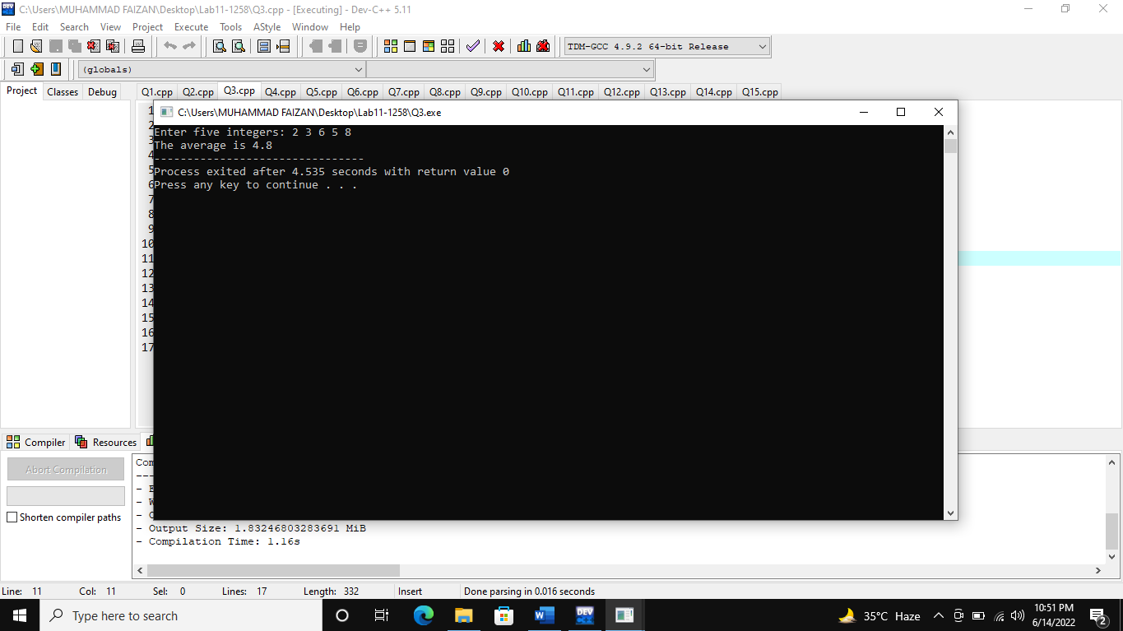

**(Q4)**

#include<iostream>

using namespace std;

void display(int *num)

{

for(int i=1;i<=*num;i++)

{

cout<<"#"<<endl;

}

}

int main()

{

int a;

for(int i=1;i<=5;i++)

{

cout<<"Enter integer number(between 1 to 20) "<<i<<" : ";

cin>>a;

display(&a);

}

}

**Output**

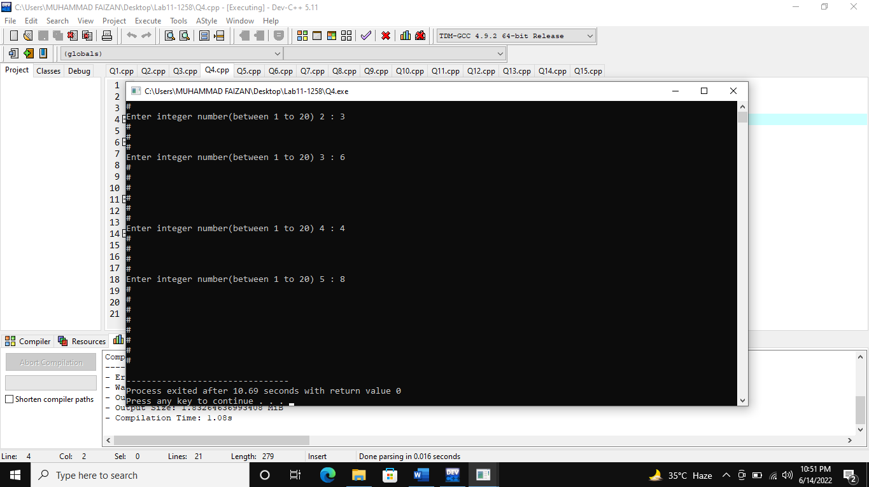

**(Q5)**

#include<iostream>

using namespace std;

void fact(int *num)

{

int fact=1;

for(int i=1;i<=*num;i++)

{

fact=fact*i;

}

cout<<"Factorial is "<<fact;

}

int main()

{

int num;

cout<<"Enter a number for factorial : ";

cin>>num;

fact(&num);

}

**Output**

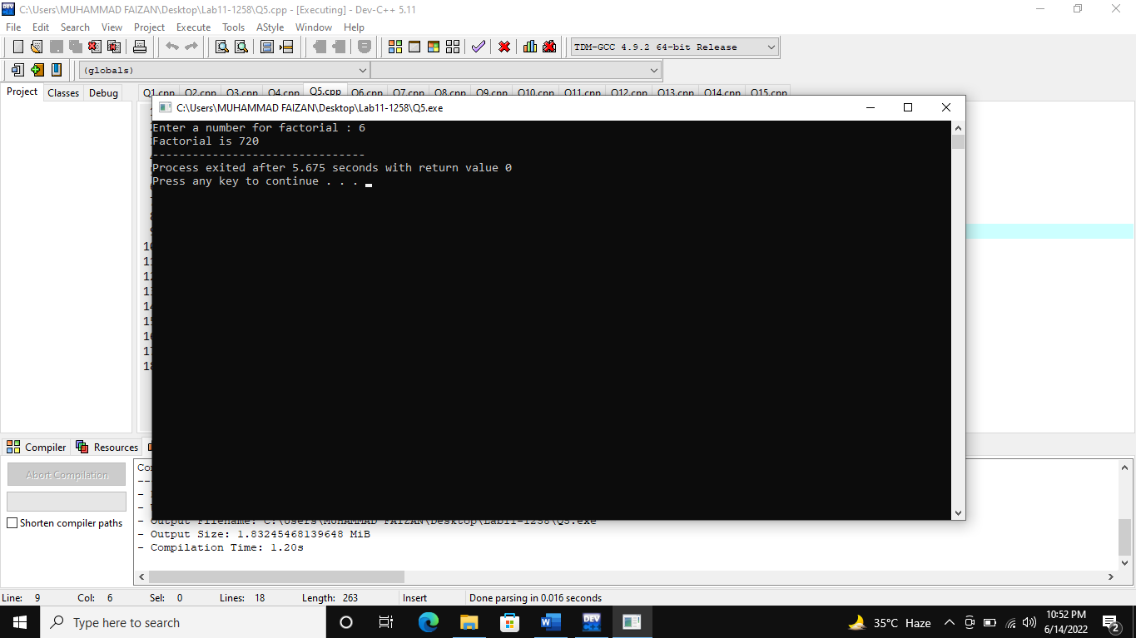

**(Q6)**

#include<iostream>

using namespace std;

float area(int *r)

{

float pi=3.1416;

float area;

area=pi*(*r)*(*r);

cout<<"Area of circle is "<<area;

}

int main()

{

int r;

cout<<"Enter the radius ";

cin>>r;

area(&r);

}

**Output**

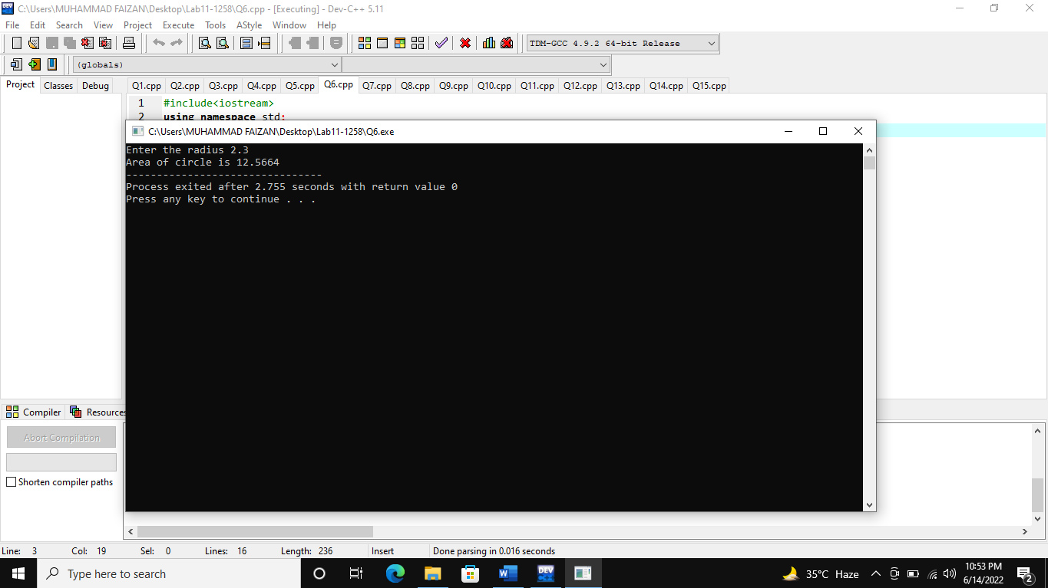

**(Q7)**

#include<iostream>

using namespace std;

bool multiple(int *num1, int *num2)

{

if(*num1%*num2==0)

{

return 1;

}

else if(*num1!=*num2)

{

return 0;

}

}

int main()

{

int a,b;

cout<<"Enter Two numbers ";

cin>>a>>b;

int x=multiple(&a,&b);

if(x==true)

{

cout<<"The first number is multiple of other"<<endl;

}

else

{

cout<<"The first number is not multiple of other";

}

}

**Output**

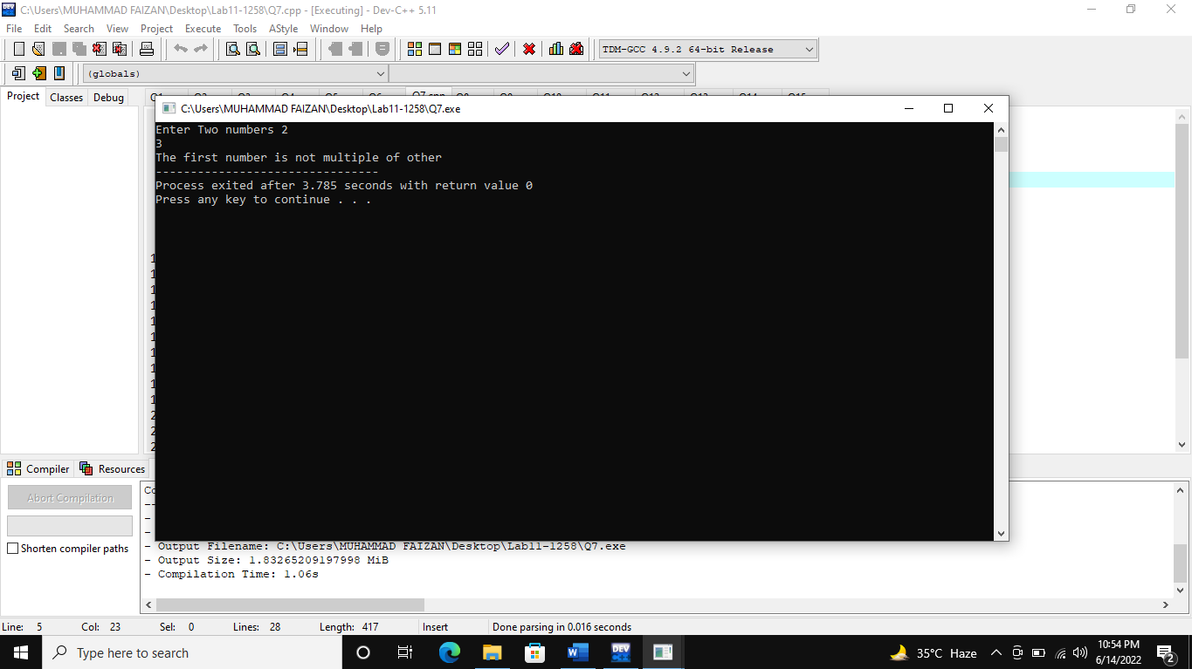

**(Q8)**

#include<iostream>

using namespace std;

int main()

{

float *ptr1,*ptr2;

float a=10.5;

ptr1=&a;

ptr2=ptr1;

*ptr1=*ptr2+3.5;

cout<<"Result is "<<*ptr1;

}

**Output**

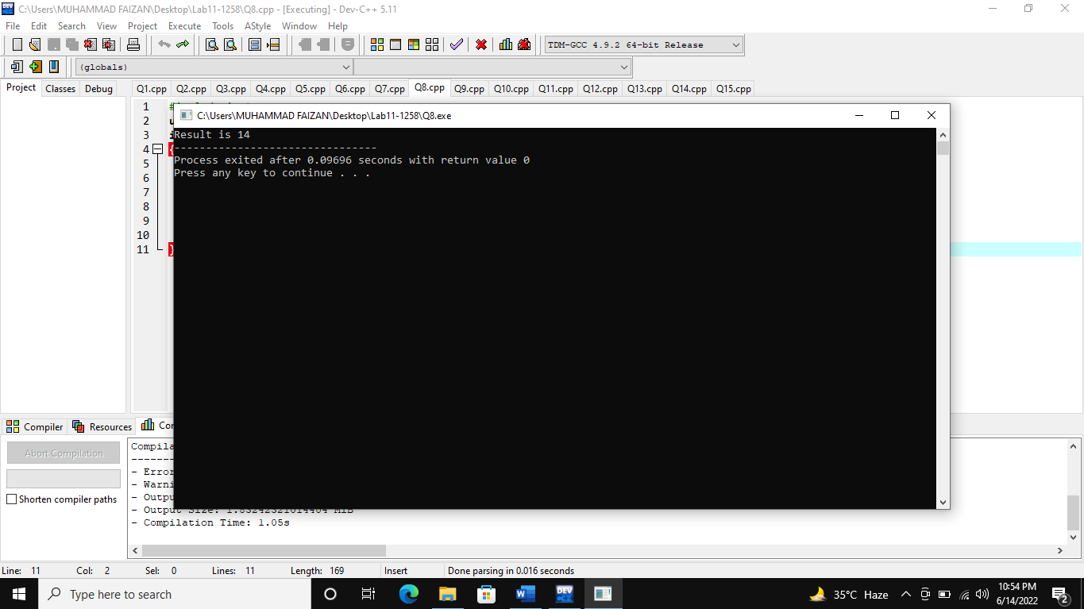

**(Q9)**

#include<iostream>

using namespace std;

int main()

{

int *ptr;

int a=10;

ptr=&a;

cout<<"Next adress is "<<endl;

cout<<ptr+1<<endl;

cout<<"Previous adress is "<<endl;

cout<<ptr-1;

}

**Output**

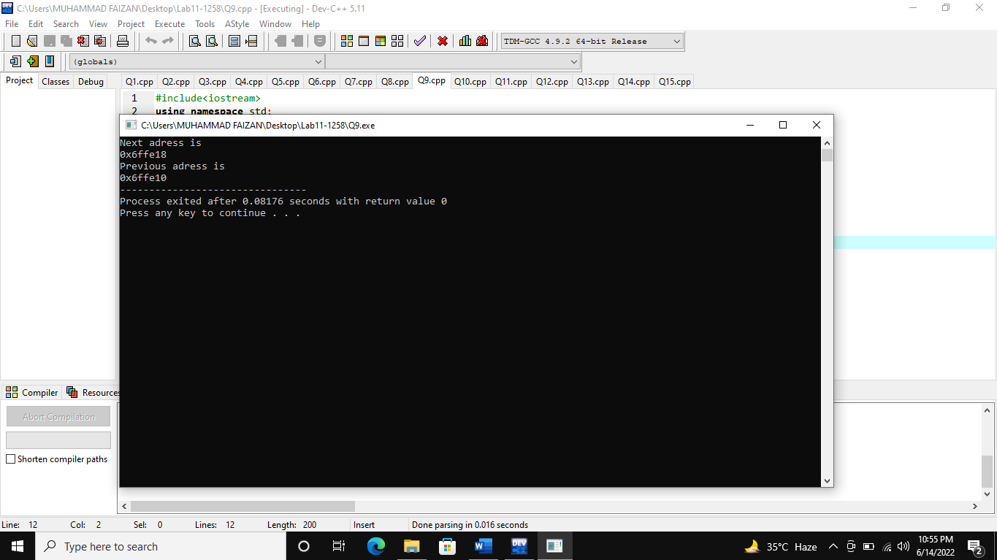

**(Q10)**

#include<iostream>

using namespace std;

int main()

{

double arr[5];

cout<<"Enter Array ";

for(int i=0;i<=4;i++)

{

cin>>arr[i];

}

double *ptr;

ptr=arr;

cout<<"Elements are "<<endl;

for(int i=0;i<=4;i++)

{

cout<<*ptr<<endl;

*ptr++;

}

}

**Output**

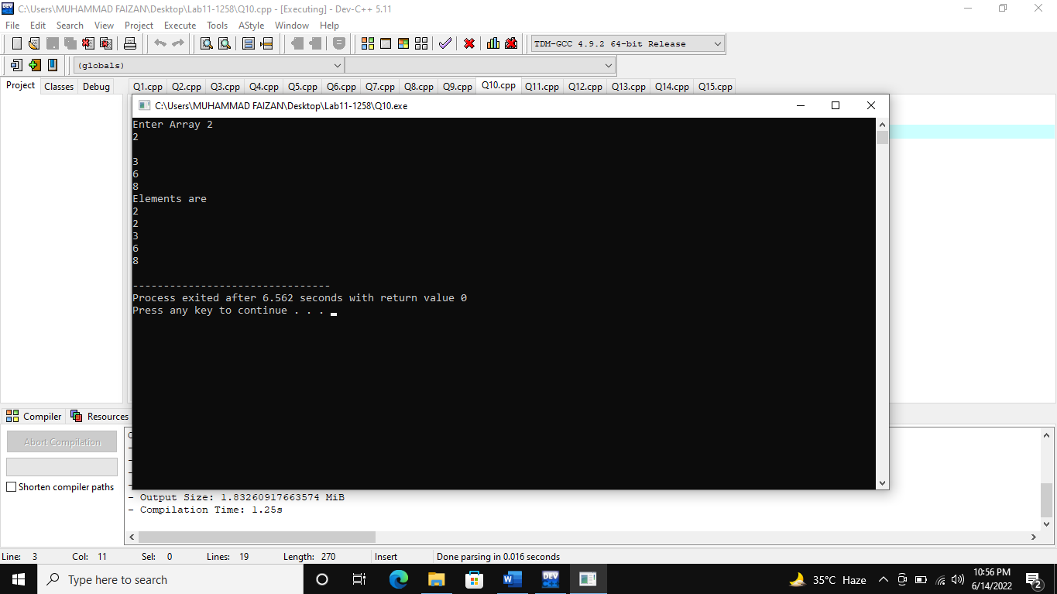

**(Q11)**

#include<iostream>

using namespace std;

int main()

{

int arr[10];

cout<<"Enter Array ";

for(int i=0;i<=9;i++)

{

cin>>arr[i];

}

int *ptr;

ptr=arr;

cout<<"Third element of array is "<<*(ptr+2)<<endl;

cout<<"fifth element of array is "<<*(ptr+4)<<endl;

cout<<"tenth element of array is "<<*(ptr+8)<<endl;

}

**Output**

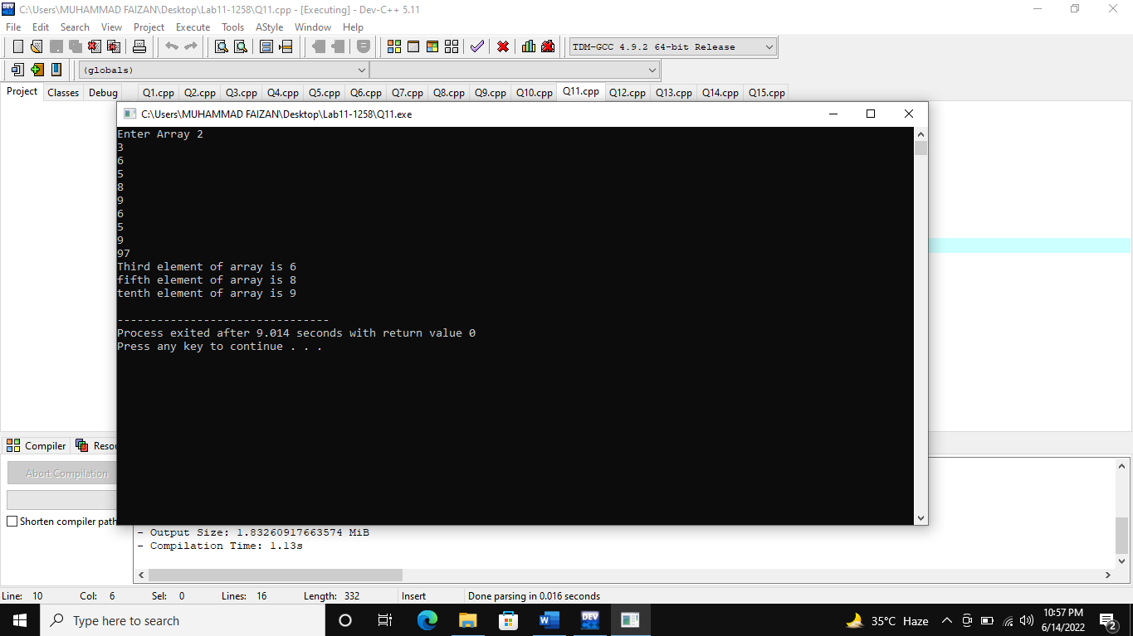

**(Q12)**

#include<iostream>

using namespace std;

int main()

{

int a[]={1,2,3,4,5};

int *ptr;

ptr=&a[4];

cout<<"Reverse is "<<endl;

for(int i=0;i<=4;i++)

{

cout<<*(ptr-i)<<endl;

}

}

**Output**

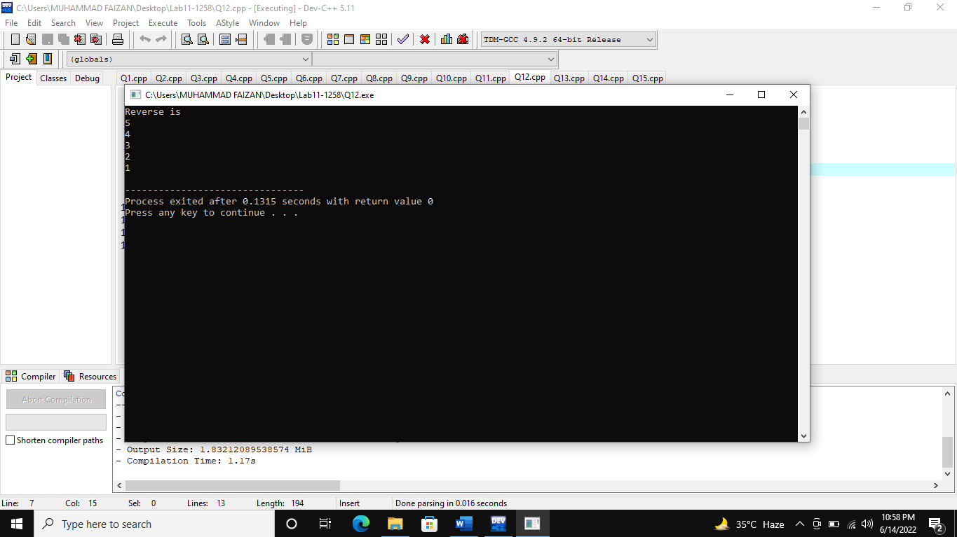

**(Q13)**

#include<iostream>

using namespace std;

int main()

{

char a[]="this is a text code";

char *ptr;

ptr=&a[18];

cout<<"Reverse is "<<endl;

for(int i=0;i<=18;i++)

{

cout<<*(ptr-i);

}

}

**Output**

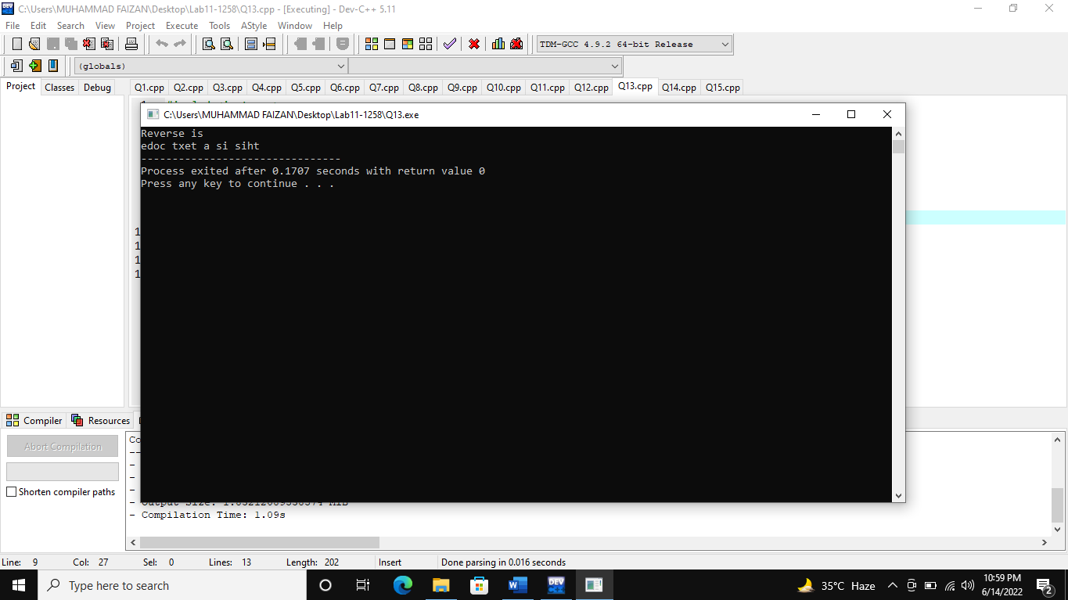

**(Q14)**

#include<iostream>

using namespace std;

void avg (float *ptr1, float *ptr2, float *ptr3){

cout<<"Average is : "<<(*ptr1+*ptr2+*ptr3)/3;

}

int main(){

float array[10];

cout<<"Enter value of array : ";

for(int i=0; i<10; i++){

cin>>array[i];

}

avg(&array[0],&array[4],&array[9]);

return 0;

}

**Output**

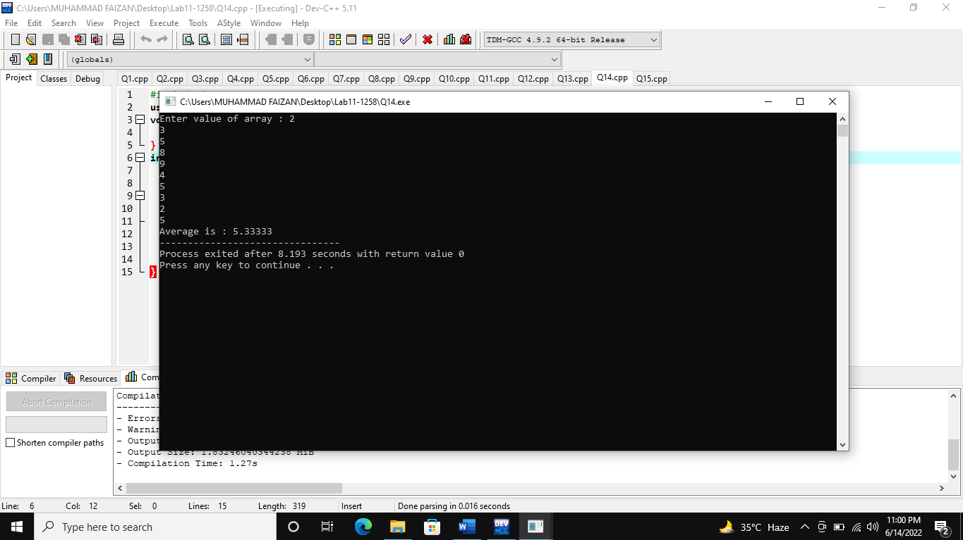

**(Q15)**

#include<iostream>

using namespace std;

void swap (int *ptr1, int *ptr2){

int temp = *ptr1;

*ptr1=*ptr2;

*ptr2=temp;

}

int main(){

int array[5], array2[5];

cout<<"Enter value of array : ";

for(int i=0; i<5; i++){

cin>>array[i];

}

cout<<"Enter value of 2nd array array : ";

for(int i=0; i<5; i++){

cin>>array2[i];

}

swap(array,array2);

for(int i=0; i<5; i++){

cout<<array[i];

}

cout<<endl;

for(int i=0; i<5; i++){

cout<<array2[i];

}

return 0;

}

**Output**

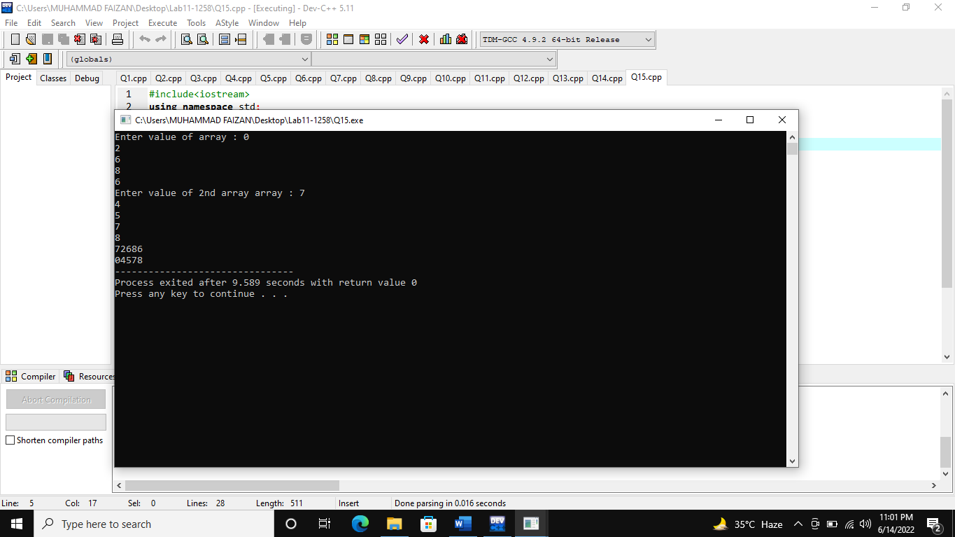

**(Q16)**

#include<iostream>

using namespace std;

void input(int *ptr){

cout<<"Enter 5 elements of array : ";

for(int i=0; i<5; i++,ptr++){

cin>>*ptr;

}

}

void output(int *ptr){

cout<<"Five elements of array are : ";

for(int i=0; i<5; i++,ptr++){

cout<<*ptr<<" ";

}

}

int main(){

int array[5];

input(array);

output(array);

return 0;

}

**Output**

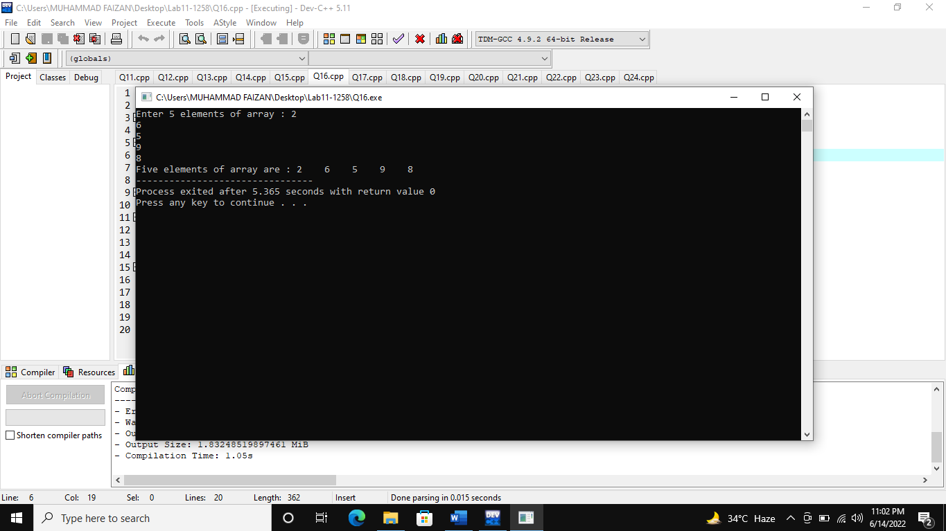

**(Q17)**

#include<iostream>

using namespace std;

int main(){

int *ptr1,*ptr2,*ptr3;

ptr1= new int;

ptr2= new int;

ptr3= new int;

*ptr1= 10;

*ptr2= 10;

*ptr3= 10;

cout<<"Sum is : "<<*ptr1+*ptr2+*ptr3;

return 0;

}

**Output**

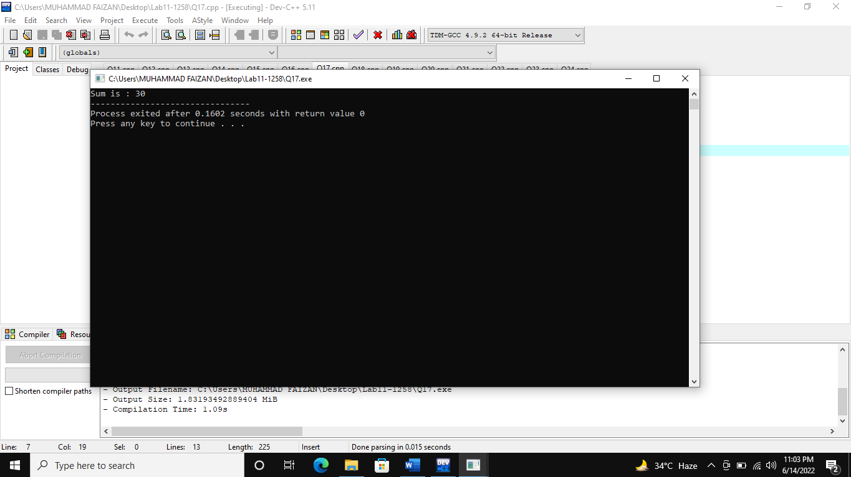

**(Q18)**

#include<iostream>

using namespace std;

int main(){

char *ptr1,*ptr2,*ptr3;

ptr1= new char;

ptr2= new char;

ptr3= new char;

*ptr1= 'A';

*ptr2= 'B';

*ptr3= 'C';

cout<<"Value of first ptr is : "<<*ptr1<<endl;

cout<<"Value of second ptr is : "<<*ptr2<<endl;

cout<<"Value of third ptr is : "<<*ptr3;

return 0;

}

**Output**

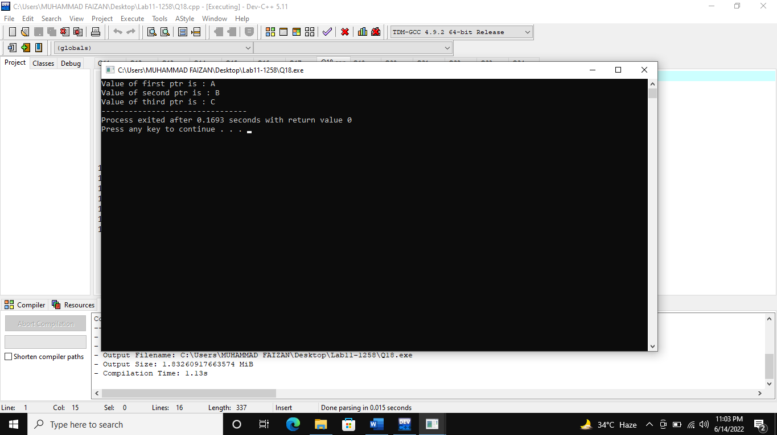

**(Q19)**

#include<iostream>

using namespace std;

void large (int *ptr1, int *ptr2,int *ptr3,int *ptr4,int *ptr5 ){

int large = *ptr1;

if(*ptr2>large)

large=*ptr2;

if(*ptr3>large)

large=*ptr3;

if(*ptr4>large)

large=*ptr4;

if(*ptr5>large)

large=*ptr5;

cout<<"Largest number is : "<<large;

}

int main(){

int *ptr1,*ptr2,*ptr3,*ptr4,*ptr5;

ptr1= new int;

ptr2= new int;

ptr3= new int;

ptr4= new int;

ptr5= new int;

cout<<"Enter values of five pointers : ";

cin>>*ptr1>>*ptr2>>*ptr3>>*ptr4>>*ptr5;

large(ptr1,ptr2,ptr3,ptr4,ptr5);

return 0;

}

**Output**

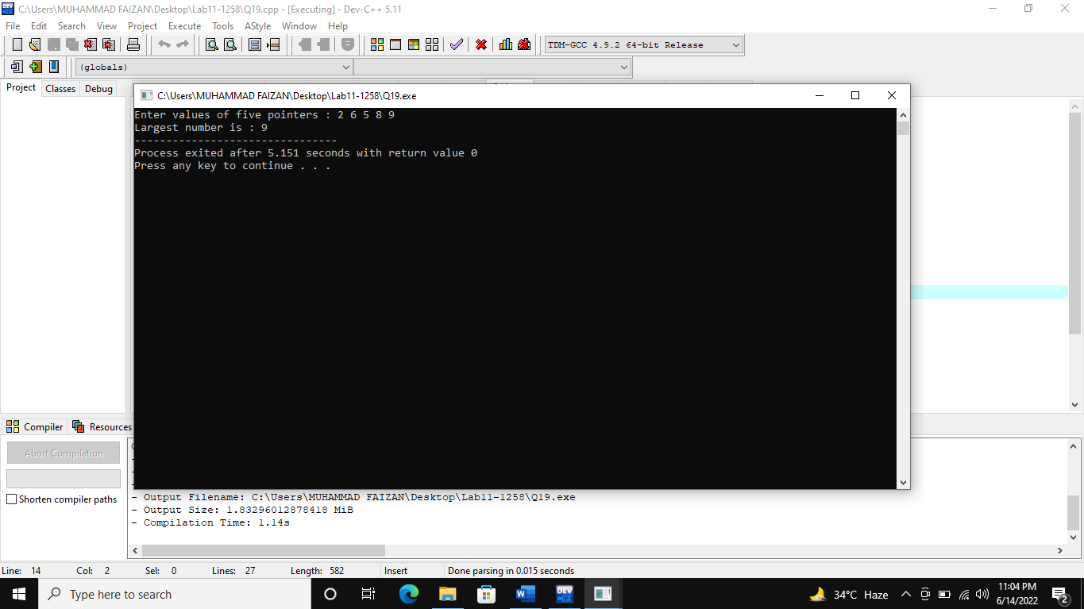

**(Q20)**

#include<iostream>

using namespace std;

void input(int *ptr){

cout<<"Enter 10 elements of array : ";

for(int i=0; i<10; i++,ptr++){

cin>>*ptr;

}

}

void output(int *ptr){

cout<<"10 elements of array are : ";

for(int i=0; i<10; i++,ptr++){

cout<<*ptr<<" ";

}

}

int main(){

int *array{new int[10]};

// array[10]=new int;

input(array);

output(array);

return 0;

}

**Output**

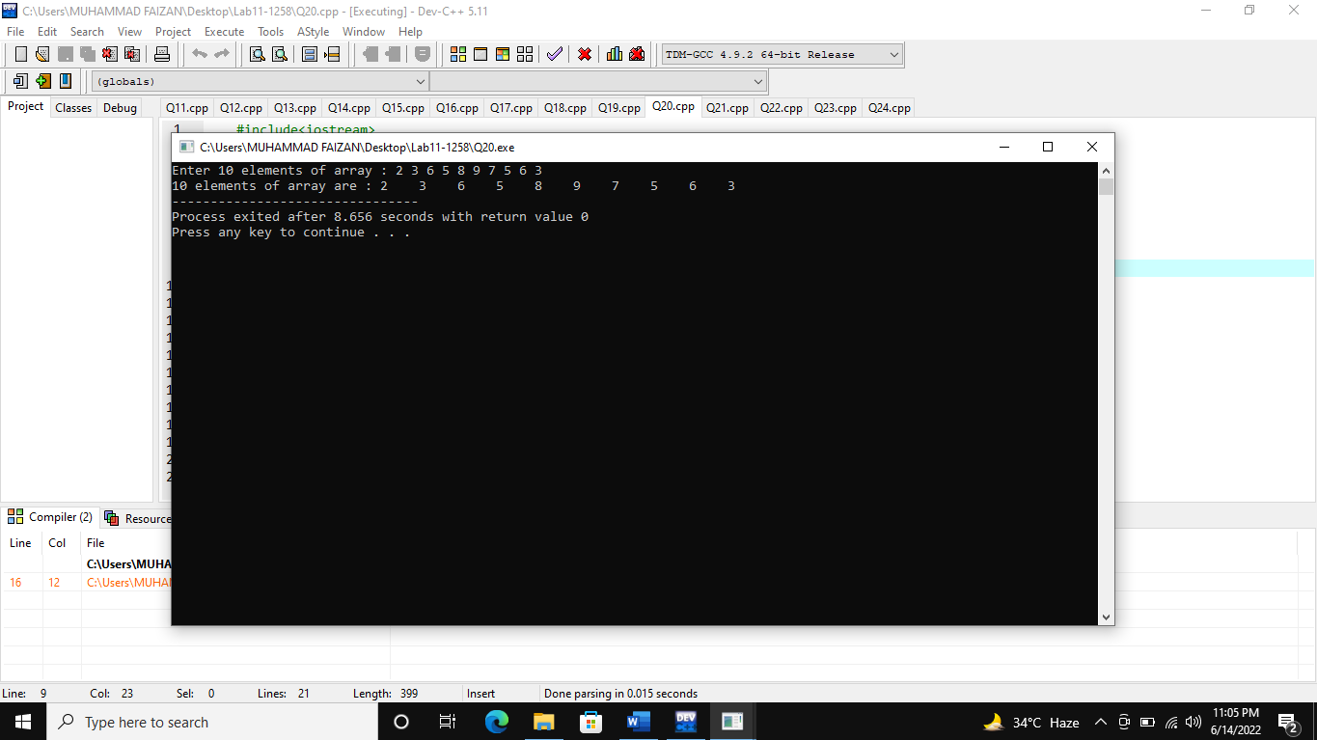

**(Q21)**

#include<iostream>

using namespace std;

int main(){

int **ptr1, *ptr, var=10;

ptr=&var;

*ptr=*ptr+50;

ptr1=&ptr;

cout<<"Value at double pointer is : "<<**ptr1;

return 0;

}

**Output**

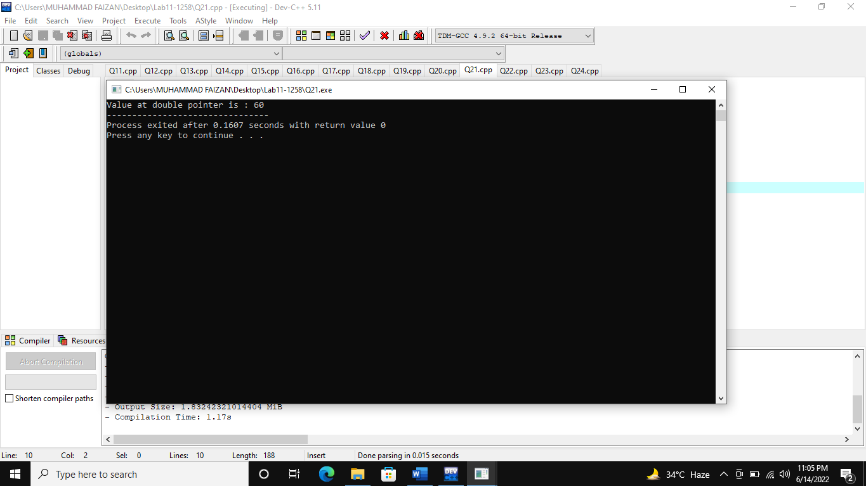

**(Q22)**

#include<iostream>

using namespace std;

int main()

{

char str[6] = "Hello";

char *ptr;

int i;

ptr = str;

for(i = 0; i<6; i++,ptr++)

cout<<*ptr;

return 0;

}

**Output**

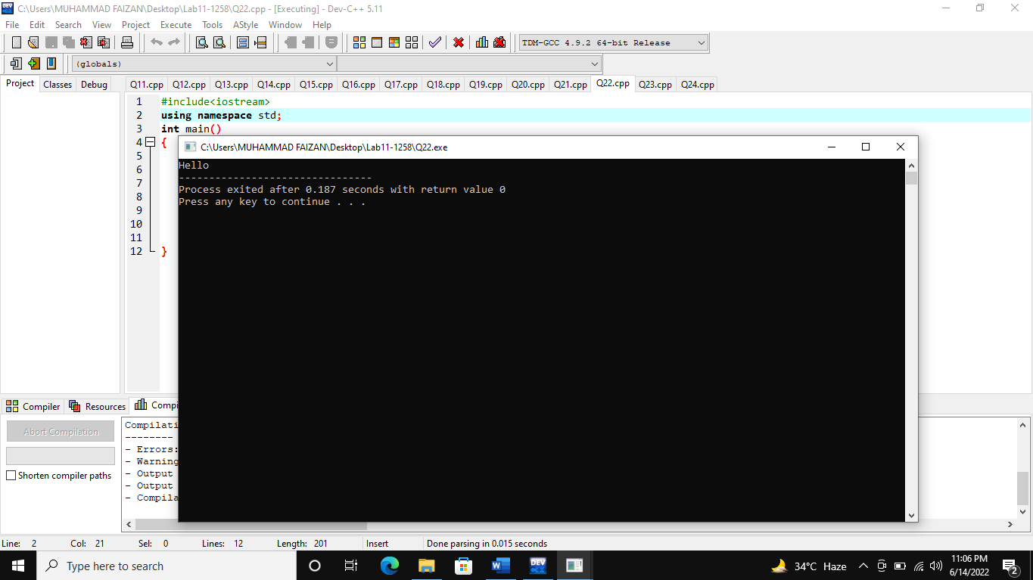

**(Q23)**

#include<iostream>

using namespace std;

int main (){

char *Cptr1,*Cptr2;

char arr[20];

Cptr1=arr;

cout<<"Enter the character array: ";

gets(Cptr1);

Cptr2=Cptr1;

cout<<"\nThe array is: "<<Cptr2<<endl;

return 0;

}

**Output**

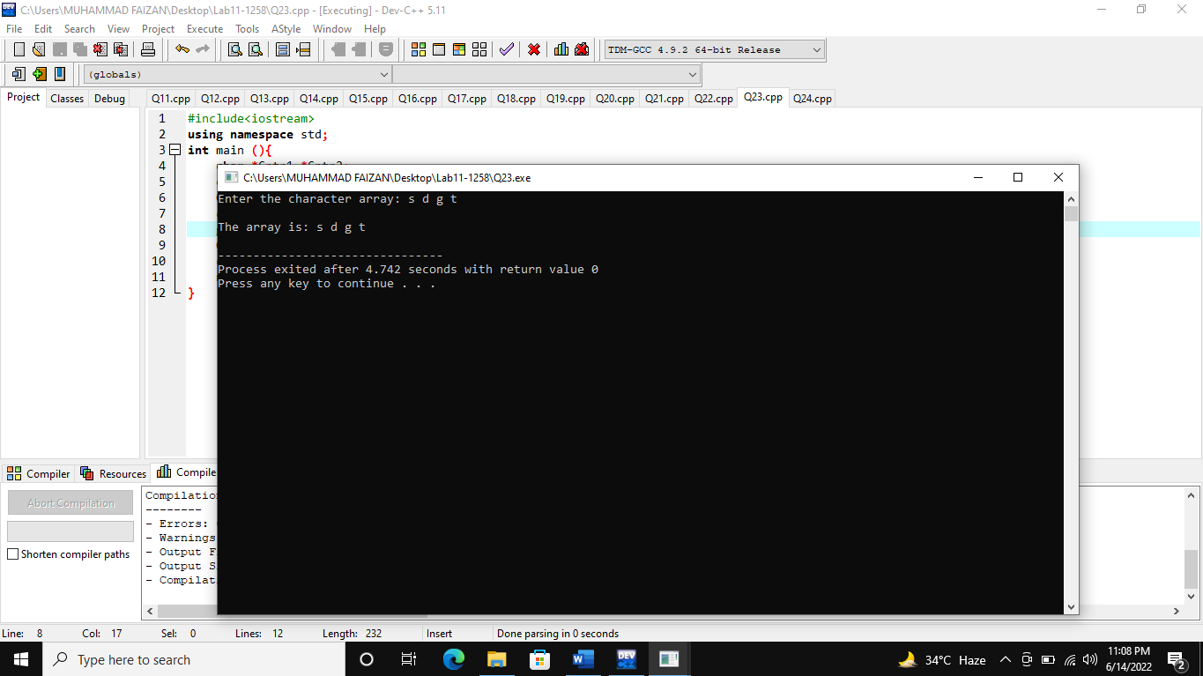

**(Q24)**

#include<iostream>

using namespace std;

int main (){

char *Cptr1,*Cptr2;

char arr[20];

Cptr1=arr;

cout<<"Enter the array: ";

gets(Cptr1);

for(int i=0;i<5;i++){

Cptr2=Cptr1;

cout<<*Cptr2;

Cptr1++;

Cptr2++;

}

return 0;

}

**Output**

